Systems Analysis
Major Assignment
CSI1241

Requirements Specification
Version: 2.1.0
Prepared by:
To Be Confirmed
Submitted to:
Priya Rabadia

Tutorial: ES Off-campus

Student no. | Student name:
10371381 | Martin Ponce
10359993 | Francois Pero
10372148 | Adam Johnson
10378977 | Greg Snader

Date of submission:
<Date>

Distribution List

A list of the people that have been issued a copy of this document, in what format, what version and when was it sent.
Who | What (hard/soft copy) | Version | When
Priya Rabadia | Soft copy | 0.5.1 | 29/8/14
Dr. Mike Johnstone
Martin Ponce | Soft copy | 0.1.0 | 20/8/14
Francois Pero | Soft copy | 0.3.0 | 27/8/14
Adam Johnson | Soft copy | 0.3.0 | 27/8/14
Greg Snader | Soft copy | 0.3.0 | 27/8/14

Modification History

Who | What | Version | When
Martin Ponce | Initial version. Added functional, non-functional requirements, Assumptions and Out-of-scope. Added glossary terms. | 0.1.0 | 20/8/14
Martin Ponce | Added iOS functional, non-functional requirements, iOS assumptions and iOS out of scope. Added glossary terms. Modified list format from unordered to ordered. Updated TOC. | 0.2.0 | 21/8/14
Martin Ponce | Rewrote functional, non-functional requirements, assumptions and out-of-scope for the development of iOS application. Updated TOC. Updated References. | 0.3.0 | 25/8/14
Francois Pero | Added introduction and assumption 4.1.1 point 4. | 0.4.0 | 27/8/14
Adam Johnson | Added Project Scope, Glossary Terms, Modified Introduction. Minor edits to Sections 3.0 & 4.0 | 0.5.0 | 29/8/14
Martin Ponce | Defined EmployeeID as employee unique identifier. | 0.5.1 | 29/8/14
Martin Ponce | Updated and reformatted functional and non-functional requirements per Priya’s feedback. Removed APP from glossary. | 0.6.0 | 1/9/14
Martin Ponce | Added 5.0 Use Case Diagram draft v1 and 5.2 Elaborated Use Case: Search Client Records. Added Client registration as out of scope. | 0.7.0 | 7/9/14
Greg Snader | Added Lab manager account creation to 3.3 Out of scope items, point 6. Added Use Case Diagram draft v2. | 0.8.0 | 8/9/14
Francois Pero | Added 5.1 Elaborated Use Case: Log In To Application, added 11 items to 7.1 Elementary Data Dictionary, added 7.2 Composite Data Dictionary draft. | 0.9.0 | 10/9/14
Greg Snader | Added 5.3 Elaborated Use Case: View Invoice, 5.4 Elaborated Use Case: Pay Invoice. | 1.0.0 | 12/9/14
Martin Ponce | Updated Use Case diagram to include “Pay invoice” extension points. | 1.1.0 | 12/9/14
Martin Ponce | Added 6.0 Navigation Map (draft) | 1.2.0 | 22/9/14
Martin Ponce | Added 6.1 App Screen: Log In | 1.3.0 | 25/9/14
Martin Ponce | Added 6.2 App Screen: Client Home, updated 6.0 Navigation Map draft and 9.0 References. | 1.4.0 | 26/9/14
Martin Ponce | Added 6.3 App Screen: Lab Manager Home | 1.5.0 | 29/9/14
Martin Ponce | Added 6.4 App Screen: Client Search Results. Updated 5.0 Use Case Diagram and 6.0 Navigation Map | 1.6.0 | 2/10/14
Francois Pero | Added 8.1 BRD Login and 8.2 EST Log In To Application | 1.7.0 | 5/10/14
Martin Ponce | Added more 7.1 Elementary Data Dictionary definitions, updated 7.2.1 Invoice composite, added 7.2.2 Login screen, 7.2.3 Client home, 7.2.4 Lab Manager home 7.2.5 Search client results composite definitions. Removed references to AccountID, now known as EmployeeID. | 1.8.0 | 7/10/14
Greg Snader | Added 8.5 BRD View Invoice and 8.6 EST View Invoice | 1.9.0 | 7/10/14
Martin Ponce | Added 8.3 BRD Search Client Records and 8.4 EST Search Client Records. Updated 8.1 BRD Log In To Application and 8.2 EST Log In To Application | 2.0.0 | 8/10/14
Martin Ponce | Updated app screens to match some composite data definitions, updated navigation map to match some composite data definitions, reworded some composite data definitions. | 2.1.0 | 8/10/14

TABLE OF CONTENTS | Page

1.0 INTRODUCTION 7
2.0 GLOSSARY OF TERMS 7
3.0 PROJECT SCOPE 8
3.1 FUNCTIONAL REQUIREMENTS 8
3.1.1 Client must be able to log in to the application using their CCC user account login details 8
3.1.2 Client must be able to view the services provided by CCC 8
3.1.3 Client must be able to request their sample to be destroyed 8
3.1.4 Client must be able to view the status of their sample 8
3.1.5 Client must be able to securely view and pay invoices via credit card 8
3.1.6 Client Account Manager, Laboratory Technician and Laboratory Manager must be able to log in to the application using their CCC user account login details 8
3.1.7 Client Account Managers must only be able to access client details 8
3.1.8 Laboratory Technicians must only be able to access sample data and sample location records 8
3.1.9 Laboratory Managers must be able to access client and sample data records, as well as the internal audit system 8
3.1.10 Laboratory Managers must be able to verify a new employee through CCC’s HR system and create a new user account for that employee 8
3.2 NON-FUNCTIONAL REQUIREMENTS 9
3.3 OUT OF SCOPE ITEMS 9
4.0 ASSUMPTIONS 10
4.1 Client assumptions 10
4.1.1 Client registration is assumed to occur outside of the iOS application on CCC’s website 10
4.1.2 Client registration is assumed to create data records and an online account for the client that can be utilised by the iOS application 10
4.1.3 Client registration is assumed to be recorded by CCC’s internal audit system 10
4.1.4 The information and questionnaire provided by the client is reviewed by an employee of CCC before client is accepted 10
4.1.5 It is assumed that rather than emailing clients a link to a secure form to confirm their sample destruction request as outlined in the case study, the secure form will be issued to the customer from within the iOS application where it can be completed 10
4.1.6 Sample data records are assumed to contain fields that indicate the physical and testing status of client samples which can be used by the iOS application 10
4.1.7 It is assumed that there is no GST component in the invoice 10
4.1.8 It is assumed that invoices are only generated and issued electronically 10
4.1.9 It is assumed that clients are warned if their payment is overdue and sample is to be destroyed 10
4.1.10 It is assumed that clients are notified when sample is destroyed for non-payment 10
4.1.11 It is assumed that refunds are processed externally from the proposed iOS application 10
4.1.12 It is assumed that refund of pro-rata annual fee is also provided to clients after requesting their sample to be destroyed and have cancelled their storage plan 10
4.2 Employee assumptions 10
4.2.1 It is assumed that roles are specified within employee user accounts during their creation by the Laboratory Manager 10
4.2.2 It is assumed that employee user accounts are assigned a unique EmployeeID when created by the Laboratory Manager 11
4.3 Application assumptions 11
4.3.1 It is assumed that the iOS application will communicate with CCC’s servers securely using industry standard encryption 11
4.3.2 It is assumed that the iOS application will provide the user a method to reset their password if forgotten 11
5.0 USE CASE DIAGRAM 12
5.1 ELABORATION OF LOG IN TO APPLICATION USE CASE 13
5.1.1 13
5.2 ELABORATION OF SEARCH CLIENT RECORDS USE CASE 14
5.2.1 14
5.3 ELABORATION OF VIEW INVOICE USE CASE 15
5.3.1 15
5.4 ELABORATION OF PAY INVOICE USE CASE 16
5.4.1 16
5.5 ELABORATION OF <Name> USE CASE 17
6.0 NAVIGATION MAP 18
6.1 App SCREEN#1 – Log In Screen 19
6.2 App SCREEN#2 – Client Home 21
6.3 App SCREEN#3 – Lab Manager Home 23
6.4 App SCREEN#4 – Search Client Results 25
7.0 DATA DICTIONARIES 26
7.1 ELEMENTARY DATA DICTIONARY 26
7.2 COMPOSITE DATA DICTIONARY 29
7.2.1 Invoice 29
7.2.2 Login screen 30
7.2.3 Client home 30
7.2.4 Lab Manager home 30
7.2.5 Search client results 30
8.0 BUSINESS RULES DIAGRAMS 31
8.1 BRD OF LOG IN TO APPLICATION 31
8.2 EVENT SPECIFICATION TABLE OF LOG IN TO APPLICATION 32
8.3 BRD OF SEARCH CLIENT RECORDS 33
8.4 EVENT SPECIFICATION TABLE OF SEARCH CLIENT RECORDS 33
8.5 BRD OF VIEW INVOICE 34
8.6 EVENT SPECIFICATION TABLE OF VIEW INVOICE 34
8.7 BRD OF <ELABORATED USE CASE 4> 35
8.8 EVENT SPECIFICATION TABLE OF <ELABORATED USE CASE 4> 35
8.9 BRD OF <ELABORATED USE CASE 5> 35
8.10 EVENT SPECIFICATION TABLE OF <ELABORATED USE CASE 5> 35
9.0 REFERENCES 35
10.0 LOGICAL RELATIONAL DATA MODEL 36

INTRODUCTION
One paragraph. Describe the problem and the likely benefits (for the client) of this system.

Cryo Cell Corporation (CCC) wants to develop a mobile application that will enable clients and staff to perform a number of key tasks through their Apple iOS devices. Development of the application offers CCC a number of potential benefits by improving overall customer satisfaction and building the brand. The application will provide better support and improve accessibility for clients. It has the potential to improve sales by exposing clients to additional services provided by CCC. It also has the potential to increase cash flow by improving the turnaround time on invoice payment. The application also offers benefits internally by improving staff efficiency and reducing the administrative load.

GLOSSARY OF TERMS
Anything about the problem domain that your team finds in the case study or refers to in this document that your project manager at McWhirter would not know. Explain the definitions-do not just expand acronyms.

Term | Definition
CCC | Cryo Cell Corporation, the client requesting the system to be built.
EmployeeID | Unique 5 digit identifier assigned to employee when a user account is created by the Laboratory Manager.
SampleID | Unique number assigned to each sample collected from clients.
FacilityID | Unique 3 character identifier for each of CCC’s storage facilities.
FridgeID | Identifier for the storage refrigerator at a CCC storage facility. There are up to 99 fridges at any single CCC storage facility.
CSC | Cryogenic Sample Container, holds up to 16 samples and is used to store client sample for storage. Each CSC has a unique identification number.
CSC Matrix Position | Each CSC can hold up to 16 samples. A location of a particular sample stored in a CSC is identified by the CSC Matrix Position.
CCC Human Resources system | CCC’s existing system which contains a record of all current staff members and their assigned job description.
APPs | Australian Privacy Principles regulate the handling of information by Australian government agencies and some private sector organisations.
SDK | Software Development Kit is a set of software development tools that allow the creation of applications.
Corona | An SDK from Corona Labs Inc. that allows developers to build mobile applications for Apple iOS and Android devices.

PROJECT SCOPE

The application will enable existing CCC clients and staff to perform a number of key tasks through their Apple iOS devices. Existing CCC clients will be able to view services, check sample status, request sample destruction, pay invoices and send enquiries, while CCC staff will be able to search for samples, retrieve client details and examine audit records. The application will be developed using the Corona SDK which will allow future versions of the application to support Android devices.

FUNCTIONAL REQUIREMENTS

The proposed iOS application provides functions for both clients and employees. These functions are categorized below.

Client must be able to log in to the application using their CCC user account login details- This is not really a FR- Remember FR is what the system must do (What the case study requires)

Client must be able to view the services provided by CCC

Client must be able to request their sample to be destroyed

Client must be able to view the status of their sample

Client must be able to securely view and pay invoices via credit card

Client Account Manager, Laboratory Technician and Laboratory Manager must be able to log in to the application using their CCC user account login details This is not really a FR- Remember FR is what the system must do (What the case study requires)

Client Account Managers must only be able to access client details

Laboratory Technicians must only be able to access sample data and sample location records

Laboratory Managers must be able to access client and sample data records, as well as the internal audit system

Laboratory Managers must be able to verify a new employee through CCC’s HR system and create a new user account for that employee

NON-FUNCTIONAL REQUIREMENTS

- Client must be able to select between two payment methods
  - Credit card
  - Direct debit, quarterly instalments
- Client must be able to securely view and pay invoices via credit card
- Credit card payment is only accepted via MasterCard or Visa
- iOS application must be developed using Corona SDK
- The iOS application must provide encapsulation for both user types:
  - A client user type must not be able to access employee functions
  - An employee user type must not be able to access client functions
- The iOS application must provide the client with a secure online form to complete to confirm the destruction of their sample,
- The iOS application must notify CCC that the confirmation form has been completed to allow for prompt destruction of sample

  - OUT OF SCOPE ITEMS

- Client registration
- Generate printed invoices
- Interfacing with bank/s to generate refunds
- Track shipping
- Access requirements for employees that are not Client Account Managers, Lab Technicians and Lab Managers
- Lab manager ability to create new staff users through the proposed iOS application
- Monitoring storage climates and temperatures
- The development of an iPad version of the application
- The development of the application on the Android platform
- The development of the application on desktop environments ie. Windows/OSX
- Modification of CCC’s existing systems and processes

ASSUMPTIONS

Client assumptions

Client registration is assumed to occur outside of the iOS application on CCC’s website

Client registration is assumed to create data records and an online account for the client that can be utilised by the iOS application

Client registration is assumed to be recorded by CCC’s internal audit system

The information and questionnaire provided by the client is reviewed by an employee of CCC before client is accepted

It is assumed that rather than emailing clients a link to a secure form to confirm their sample destruction request as outlined in the case study, the secure form will be issued to the customer from within the iOS application where it can be completed

Sample data records are assumed to contain fields that indicate the physical and testing status of client samples which can be used by the iOS application

It is assumed that there is no GST component in the invoice

It is assumed that invoices are only generated and issued electronically

It is assumed that clients are warned if their payment is overdue and sample is to be destroyed

It is assumed that clients are notified when sample is destroyed for non-payment

It is assumed that refunds are processed externally from the proposed iOS application

It is assumed that refund of pro-rata annual fee is also provided to clients after requesting their sample to be destroyed and have cancelled their storage plan

Employee assumptions

It is assumed that roles are specified within employee user accounts during their creation by the Laboratory Manager

It is assumed that employee user accounts are assigned a unique EmployeeID when created by the Laboratory Manager

Application assumptions

It is assumed that the iOS application will communicate with CCC’s servers securely using industry standard encryption

It is assumed that the iOS application will provide the user a method to reset their password if forgotten

USE CASE DIAGRAM

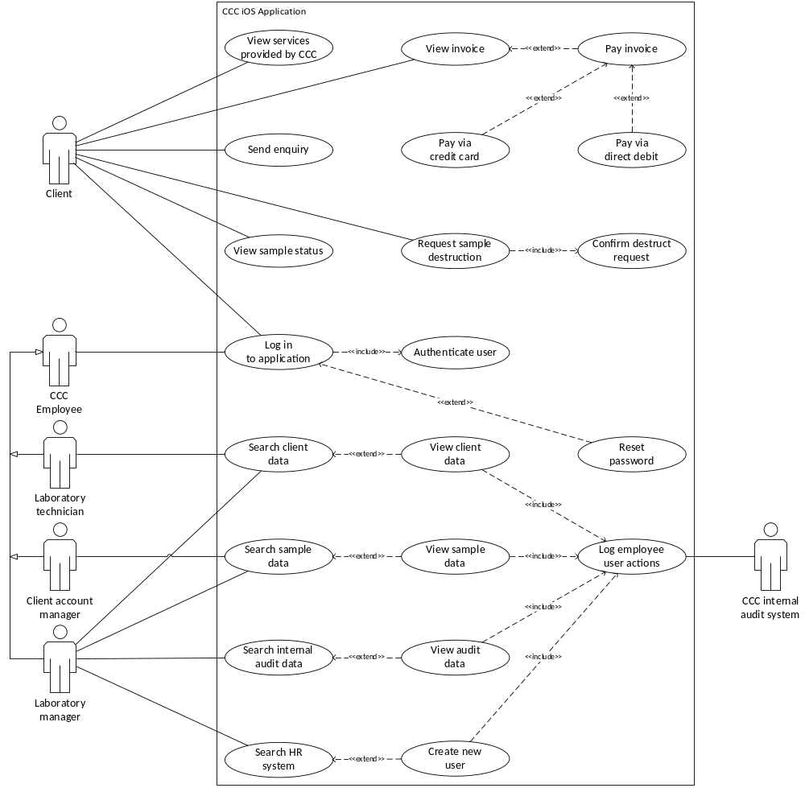

ELABORATION OF LOG IN TO APPLICATION USE CASE

Use case: Log in to application
Actor(s): Client, CCC Employee
Purpose: This use case allows both Clients and CCC Employee users to log in to the application.
Overview: Client or CCC Employee enters account details which is then authenticated by the system. If the details are correct, the system identifies the user type and provides access to the application according to the user’s type.
Preconditions: Client or CCC Employee is logged out of the application and is attempting to log in.
Postconditions: Client or CCC Employee is logged in to the system and is provided access according to their user type.

Typical Course of Events

Actor Action | System Response
1. Client or CCC Employee enters username and password  Extension point: Reset password | 2. System authenticates details  Include: Authenticate user
 | 3. If details are correct, system identifies user type, either Client or CCC Employee
 | 4. System signs in Client or CCC Employee to application according to user type

Alternative Courses

- Step 1: User may choose to reset password, go to reset password use case.
- Step 3: If Client or CCC Employee details are incorrect and fails. authentication, display message “Incorrect username and password”, go to Step 1. After 3 failed authentication attempts, use case ends.

Related Use Cases

Inclusions: Authenticate user
Extensions: Reset password

ELABORATION OF SEARCH CLIENT RECORDS USE CASE

Use case: Search Client Records
Actor(s): Client Account Manager,
Purpose: This use case allows the Client Account Manager to search for client records on the iOS application
Overview: Client account manager enters client search query then system displays search results. Client account manager views client data and the system logs user actions
Preconditions: Client account manager has logged in successfully to the application and wishes to search for client information
Postconditions: Client account manager locates and views client data, and user activity is logged by CCC internal audit system

Typical Course of Events

Actor Action | System Response
1. Client account manager enters client search query | 2. System provides search query results
3. Client account manager selects search query result  Extension point: View client record | 4. System displays client data
 | 5. System logs employee username/employeeID, timestamp, access type and accessed clientID
6. System sends logged data to CCC internal audit system
Include: Log user actions

Alternative Courses

- Step 1: Client account manager cancels search, end use case
- Step 2: Search query provides zero results, system displays message “No results found”, return to step 1, end use case
- Step 3: Client account manager cancels search, end use case

Related Use Cases

Inclusions: Log user actions
Extensions: View client record

ELABORATION OF VIEW INVOICE USE CASE

Use case: View Invoice
Actor(s): Client
Purpose: This use allows the client to view their current invoice.
Overview: The client selects the option to view their invoice, the system will then display the customer’s current invoice. If an outstanding balance exists, the system provides the client an option to pay. This use case concludes (or ends) when the client either cancels the viewing of their invoice, or once the client selects the option to pay the invoice.
Preconditions: The client has logged in to their account successfully.
The client selects the option to view their current invoice.
Postconditions: Client is returned to the previous screen or viewing the payment options in the “Pay Invoice” use case.

Typical Course of Events

Actor Action | System Response
1. Client selects the option to view their invoice | 2. System displays most recent invoice
 | 3. If an outstanding balance exists, system provides customer option to pay the invoice
4. Client chooses to pay invoice
Extension Point: Pay Invoice

Alternative Courses

- Step 2: If no invoices exist for client, display message “No existing invoices”, use case ends.
- Step 2: Client chooses to cancel the viewing of their invoice, use case ends.
- Step 3: No outstanding balance exists, or client has previously opted to pay via direct debit instalment plan, client can only cancel the viewing of their invoice, use case ends.
- Step 4: Client chooses not to pay invoice, use case ends.

Related Use Cases

Inclusions: nil
Extensions: Pay invoice

ELABORATION OF PAY INVOICE USE CASE

Use case: Pay Invoice
Actor(s): Client
Purpose: This use case allows the client to pay their current invoice.
Overview: The client chooses to pay invoice after viewing the current invoice. This use case concludes (or ends) when the client cancels the payment of their invoice, or once the client successfully pays the invoice amount.
Preconditions: The client has logged in to their account successfully. The client selects the option to view their current invoice. The system has identified an outstanding balance, and the client selects the option to pay their current invoice.
Postconditions: Client is returned to their iOS application account homepage after successful payment is made or viewing the current invoice in the “View Invoice” use case if payment was not made.

Typical Course of Events

Actor Action | System Response
1. Client chooses option to pay current invoice | 2. System displays most recent invoice details and amount due
 | 3. System provides client option to pay via credit card or via direct debit instalment plan
4. Client selects to pay via credit card  Extension point: Pay via credit card  Extension point: Pay via direct debit | 5. System displays outstanding balance
 | 6. System requests client billing details and credit card type
7. Client enters required details | 8. System requests client confirmation that the details entered are correct
9. Client confirms | 10. System verifies payment details
 | 11. System accepts payment and displays payment confirmation and receipt number
12. Client acknowledges transaction confirmation and receipt | 13. System emails payment receipt to client
 | 14. System returns client to “View Invoice” use case

Alternative Courses

- Step 4: Client chooses to cancel payment, return to “View invoice” use case.
- Step 4: Client chooses to pay via direct debit, move to “Pay via direct debit” use case.
- Step 9: Client does not confirm details are correct, return to step 7.
- Step 10: System is unable to verify payment details, display message “Payment details invalid”, return to step 7.

Related Use Cases

Inclusions: nil
Extensions: Pay via credit card, Pay via direct debit.

ELABORATION OF <Name> USE CASE

NAVIGATION MAP

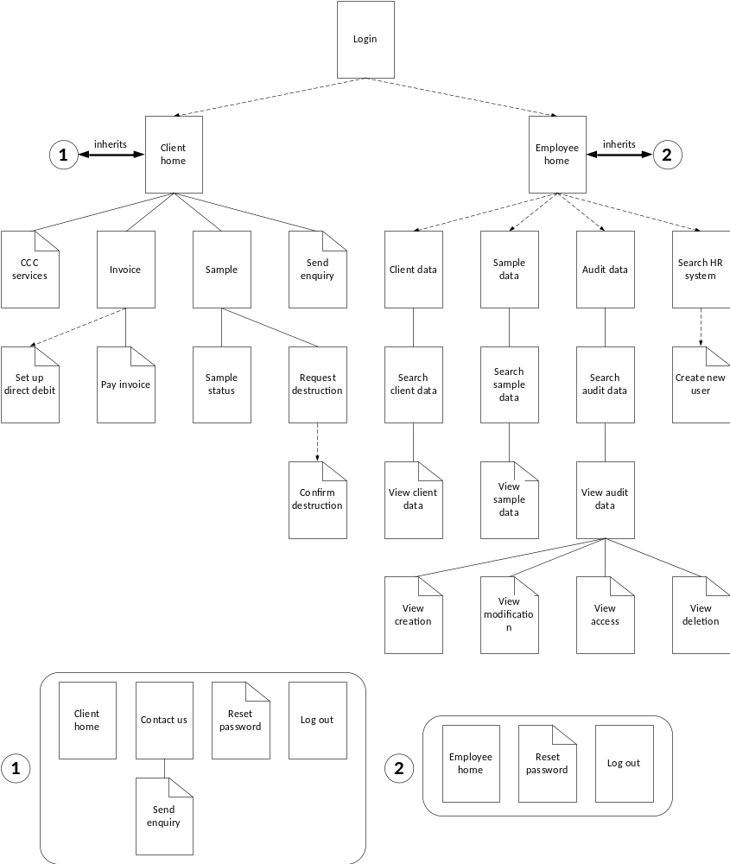

App SCREEN#1 – Log In Screen

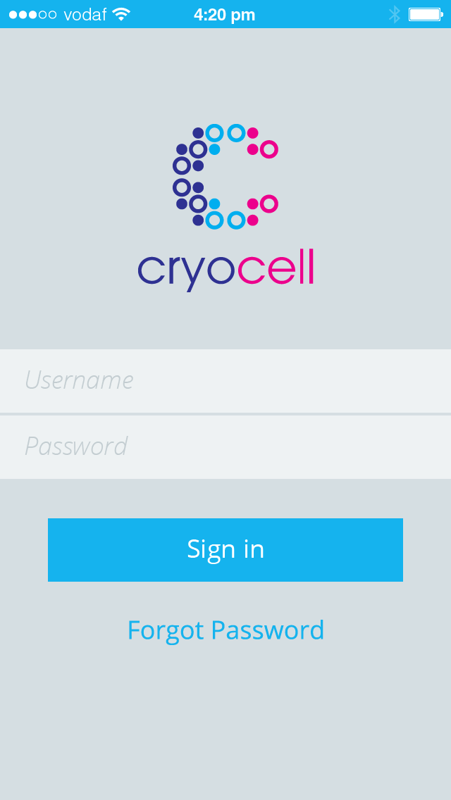

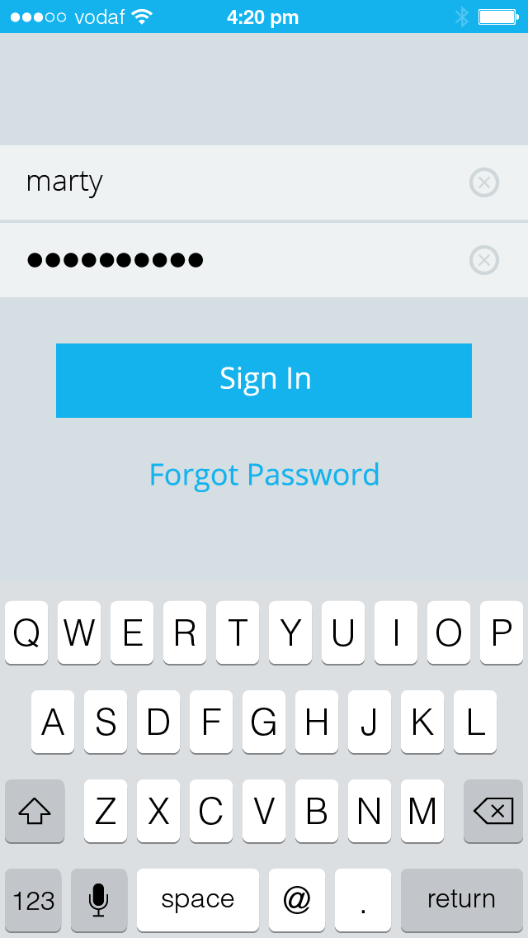

App SCREEN#2 – Client Home

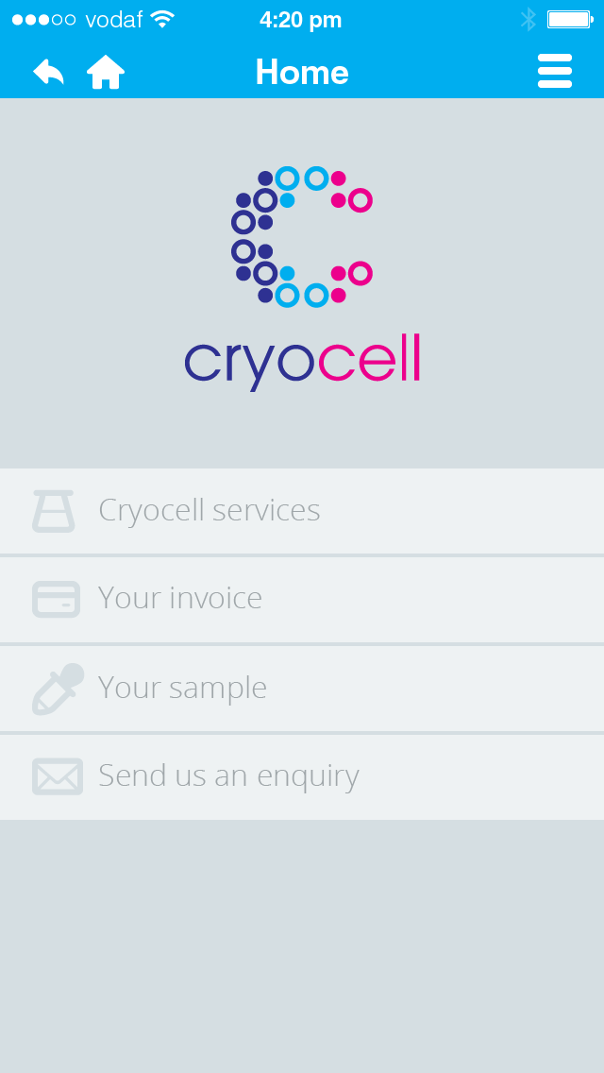

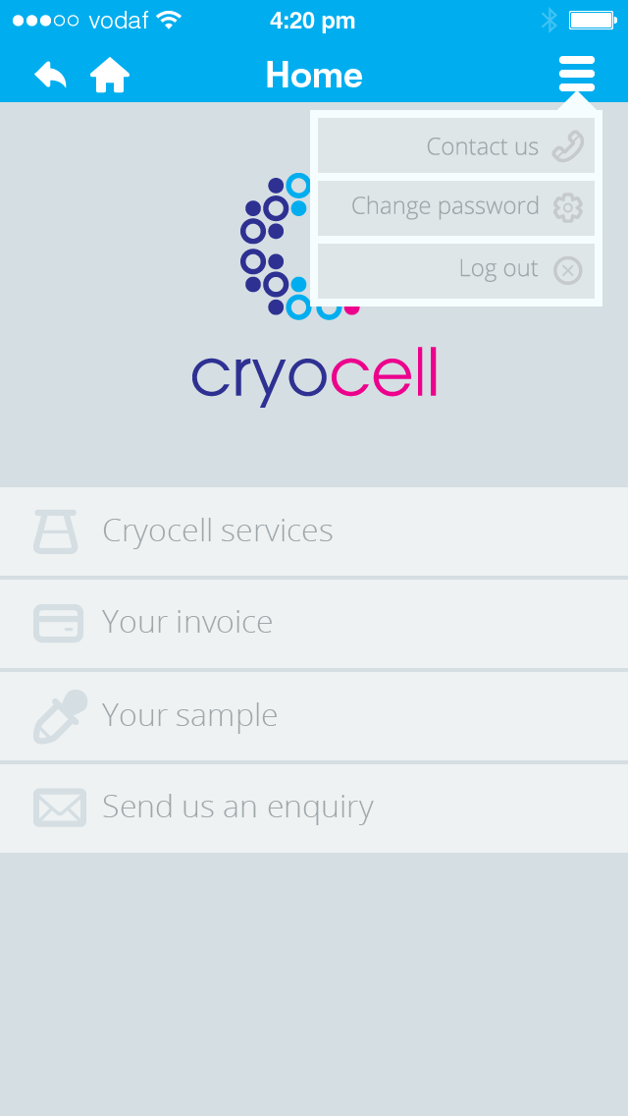

App SCREEN#3 – Lab Manager Home

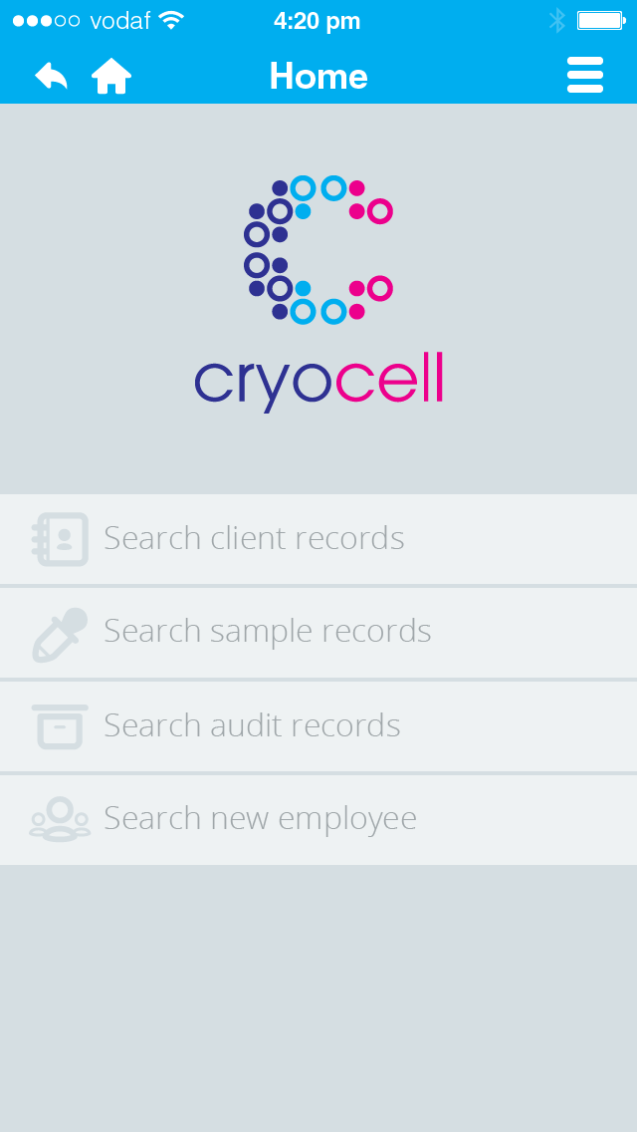

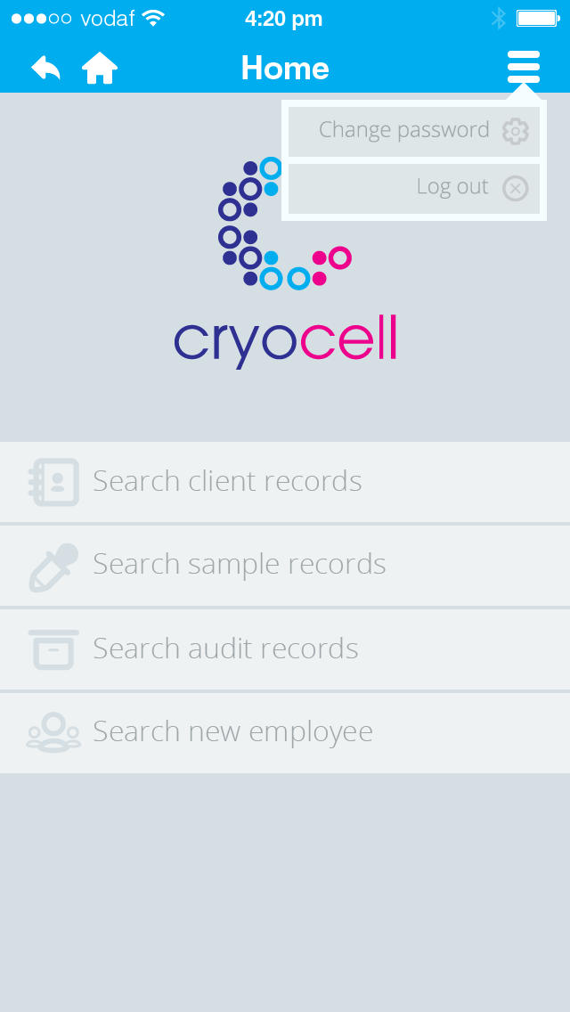

App SCREEN#4 – Search Client Results

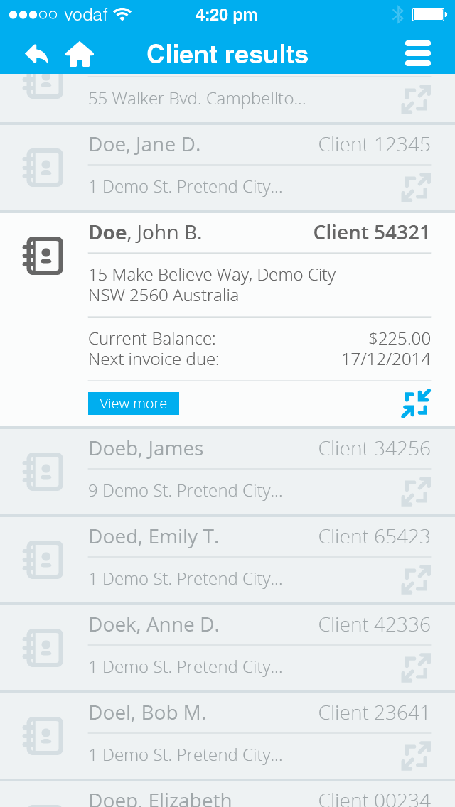

DATA DICTIONARIES

ELEMENTARY DATA DICTIONARY
Data items that fully define artefacts supplied by the client.

Name | Type | Width  (Size) | Format | Constraint
button-back | B | 1 |  | icon = back arrow
button-clear-field | B | 1 |  | icon = cross
button-home | B | 1 |  | icon = house
button-maximise | B | 1 |  | icon = maximise
button-minimise | B | 1 |  | icon = minimize
button-more | B | 9 |  | name = View more
button-sign-in | B | 7 |  | name = Sign in
client-account-balance | N | 9 | $
client-address-postcode | X | 4 | 9999
client-address-state | A | 3 |  | (WA, SA, etc) Look at the lecture slides. You should state all the States
client-address-street-name | A | 15
client-address-street-no | X | 4 | 9999 | No leading zeros if under 10
client-address-suburb | A | 20
client-address-unit-no | X | 4 | U99/ | No leading zeros if under 10
client-dob | D | 10 | dd/mm/yyyy
client-email | X | 20
client-gender | A | 1 |  | either M or F
client-id | X | 5 | 99999
client-name-given | X | 15
client-name-sirname | X | 15
client-phone-home | X | 12 | 99 9999 9999
client-phone-mobile | X | 12 | 9999 999 999
client-trustee-address | X | 12
client-trustee-dob | D | 10 | dd/mm/yyyy
client-trustee-fullname | X | 30 |  | Any X that is A, including <space>
client-trustee-phone-home | X | 12 | 99 9999 9999
client-trustee-phone-mobile | X | 12 | 9999 999 999
company-abn | X | 18 | ABN 99 999 999 999 | ABN 32 100 201 666
company-name | A | 21 |  | Cryo Cell Corporation
company-postcode | X | 4 | 9999 | 2600
company-state | A | 3 |  | ACT
company-street-name | X | 10 |  | Buxton St.
company-street-no | X | 1 | 9 | 1
company-suburb | X | 6 |  | Deakin
credit-card-csv | X | 3 | 999
credit-card-expiry | D | 10 | dd/mm/yyyy
credit-card-number | X | 20 | 9999-9999-9999-9999
credit-card-type | A | 10 |  | Either VISA or MASTERCARD
employee-id | X | 5 | 99999
employee-name-given | X | 15
employee-name-sirname | X | 15
invoice-due-date | D | 10 | dd/mm/yyyy
invoice-issue-date | D | 10 | dd/mm/yyyy | issue date of invoice
invoice-item-cost | N | 9 | $
invoice-item-name | X | 40
invoice-item-no | X | 2 | 99 | sequential, starting at 1, no leading zeros if under 10
invoice-no | X | 7
invoice-total-cost | N | 9 | $
link-ccc-services | L | 17 |  | name = Cryocell services
link-contact-us | L | 10 |  | name = Contact us
link-invoice-page | L | 12 |  | name = Your invoice
link-log-out | L | 7 |  | name = Log out
link-reset-password | L | 15 |  | name = Forgot password
link-sample-page | L | 11 |  | name = Your sample
link-search-audit | L | 20 |  | name = Search audit records
link-search-client | L | 21 |  | name = Search client records
link-search-hr | L | 19 |  | name = Search new employee
link-search-sample | L | 21 |  | name = Search sample records
link-send-enquiry | L | 18 |  | name = Send us an enquiry
pulldown-client-menu | P | 1 |  | icon = 3 lines
pulldown-employee-menu | P | 1 |  | icon = 3 lines
sample-no | X | 2 | A1 | either S1 or S2
sample-pickup-date | D | 10 | dd/mm/yyyy
sample-pickup-time | T | 5 | 99:99 | 24 hour time
sample-status-storage | A | 10 |  | either DESTROYED, IN_STORAGE, IN_TRANSIT
sample-status-test | A | 1 |  | either P = pass or F = fail
sample-status-transit | A | 9 |  | either TO_CLIENT, TO_CCC
sample-storage-csc-matrix | X | 2 |  | No leading zeros if under 10
sample-storage-csc-no | X | 5 | AAA99 | CSC99
sample-storage-date | D | 8 | yyyymmdd
sample-storage-facility | A | 3 |  | First three characters of city ie. PER
sample-storage-fridgeid | X | 3 | A99 | F99
statement-date-end | D | 10 | dd/mm/yyyy | end of invoice period
statement-date-start | D | 10 | dd/mm/yyyy | start of invoice period
title-client-page | A | 20 |  | either Home, Services, Invoice, Pay invoice, Sample, Sample status, Request destruction, Confirm destruction
title-employee-page | A | 20 |  | either Home, Client data, Client search, Client, Sample data, Sample search, Sample, Audit data, Audit search, Audit, Creation, Modification, Access, Deletion, HR search, New user
username | X | 15 |  | no <space>, only special characters allowed: - or _
userpassword | X | 15 |  | no <space>, only special characters allowed: - or _

Legend:
A | Alphabetic
N | Numeric
9 | Any digit
X | Any character
D | Date format (dd/mm/yyyy)
$ | Leading spaces
Z | Leading blank or any digit
T | Time
L | Link
B | Button
P | Pulldown menu

COMPOSITE DATA DICTIONARY
Definitions created from either elementary items or other composite items. Don’t forget to include the composite definitions of the entities in the logical relational data model here as well as the definitions of the items on the app screens.

Invoice

invoice = {invoice-header} + {client-details} + {sample-id} + {statement-date} + 1{invoice-line} + invoice-total-price

invoice-header = {company-details} + {invoice-block}

company-details = {company-address} + company-abn

invoice-block = invoice-issue-date + invoice-no + invoice-due-date

company-address = company-name + company-address-street-no + company-address-street-name + company-address-suburb + company-address-state + company-address-postcode

client-details = client-name-given + client-name-surname + {client-address-long} + client-id

client-address-long = client-address-street-no + client-address-street-name + client-address-suburb + client-address-state + client-address-postcode

sample-id = sample-no + sample-storage-date + sample-storage-facility + sample-storage-fridgeid + sample-storage-csc-no + sample-storage-csc-matrix

statement-date = statement-date-start + statement-date-end

invoice-line = invoice-item-no + invoice-item-name + invoice-item-cost

Login screen

login-screen = username + (button-clear-field) + userpassword + (button-clear-field) + button-sign-in + link-reset-password

Client home

client-home = {client-nav-bar} + link-ccc-services + link-invoice-page + link-sample-page + link-send-enquiry

client-nav-bar = button-back + button-home + title-client-page + {pulldown-client-menu}

pulldown-client-menu = link-contact-us + link-reset-password + link-log-out

Lab Manager home

lab-manager-home = {employee-nav-bar} + link-search-client + link-search-sample + link-search-audit + link-search-hr

employee-nav-bar = button-back + button-home + title-employee-page + {pulldown-employee-menu}

pulldown-employee-menu = link-reset-password + link-log-out

Search client results

search-client-results = {employee-nav-bar} + 1{client-data-line}

employee-nav-bar = button-back + button-home + title-employee-page + {button-employee-menu}

button-employee-menu = link-reset-password + link-log-out

client-data-line = {client-identifier} + [{client-address-short} | {client-address-long}] + (client-account-balance) + (invoice-due-date) + (button-more) + [button-maximise | button-minimize]

client-identifier = client-name-sirname + client-name-given + client-id

client-address-long = client-address-street-no + client-address-street-name + client-address-suburb + client-address-state + client-address-postcode

client-address-short = client-address-street-no + client-address-street-name + client-address suburb

BUSINESS RULES DIAGRAMS

BRD OF LOG IN TO APPLICATION

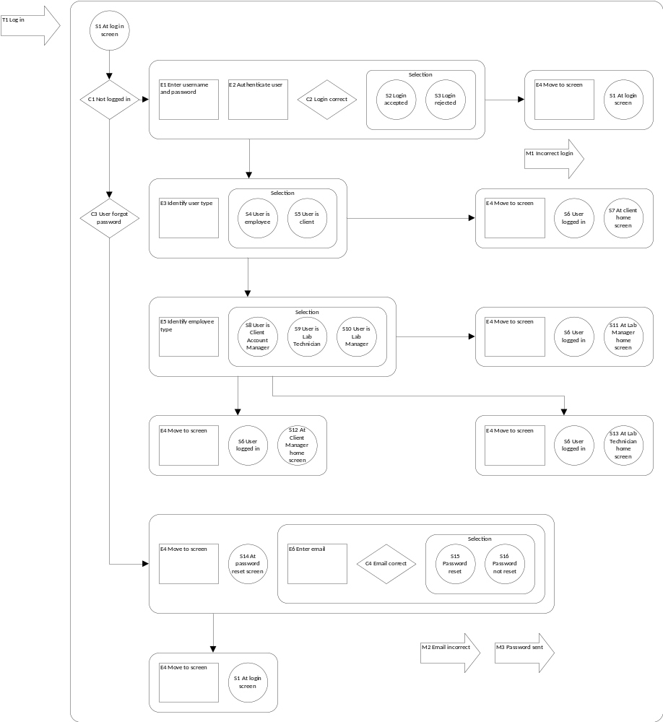

EVENT SPECIFICATION TABLE OF LOG IN TO APPLICATION

Event | Trigger | Message | Condition | Pre-state | Post-state | Rule
E1 | T1 |  | C1 | S1 | S2 | S3 | 3.1.1 & 3.1.6
E2 |  |  | C1 | S1 | S2 | S3 | 3.1.1 & 3.1.6
E3 |  |  | C2 | S2 | S4 | S5 | 3.1.1 & 3.1.6
E4 |  | M1 | !C2 | S1 | S1 | 3.1.1 & 3.1.6
E4 |  |  | C2 | S5 | S6 & S7 | 3.1.1
E4 |  |  | C2 | S10 | S6 & S11 | 3.1.6
E4 |  |  | C2 | S8 | S6 & S12 | 3.1.6
E4 |  |  | C2 | S9 | S6 & S13 | 3.1.6
E4 |  |  | C3 | S1 | S14 | 4.3.1
E4 |  | M2 | !C4 | S16 | S1 | 4.3.1
E4 |  | M3 | C4 | S15 | S1 | 4.3.1
E5 |  |  | C2 | S4 | S8 | S9 | S10 | 3.1.6
E6 |  |  | C3 | S14 | S15 | S16 | 4.3.1

BRD OF SEARCH CLIENT RECORDS

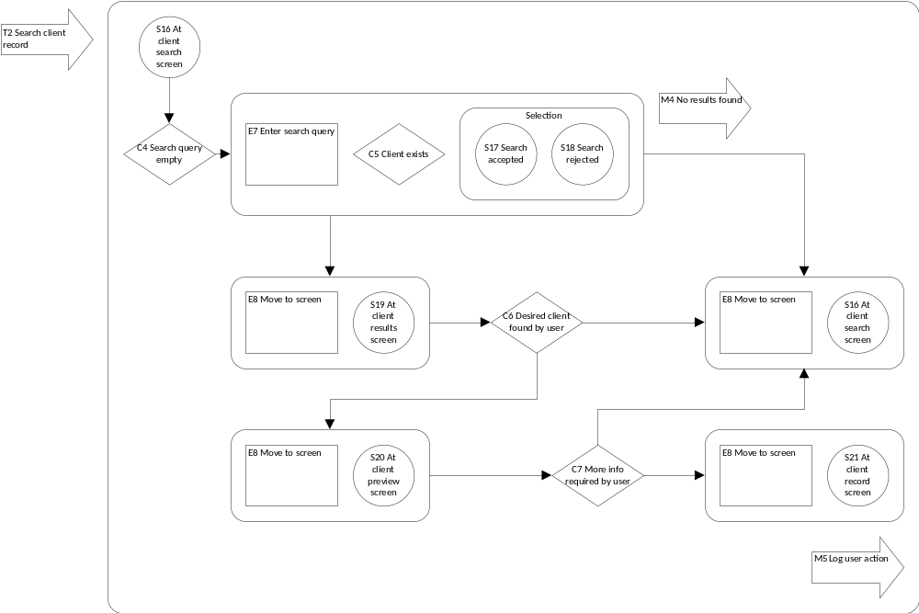

EVENT SPECIFICATION TABLE OF SEARCH CLIENT RECORDS

Event | Trigger | Message | Condition | Pre-state | Post-state | Rule
E7 | T2 |  | C4 | S16 | S17 | S18 | 3.1.7 & 3.1.9
E8 |  | M4 | !C5 | S18 | S16 | 3.1.7 & 3.1.9
E8 |  |  | C5 | S17 | S19 | 3.1.7 & 3.1.9
E8 |  |  | !C6 | S19 | S16 | 3.1.7 & 3.1.9
E8 |  |  | C6 | S19 | S20 | 3.1.7 & 3.1.9
E8 |  |  | !C7 | S20 | S16 | 3.1.7 & 3.1.9
E8 |  | M5 | C7 | S20 | S21 | 3.1.7 & 3.1.9

BRD OF VIEW INVOICE

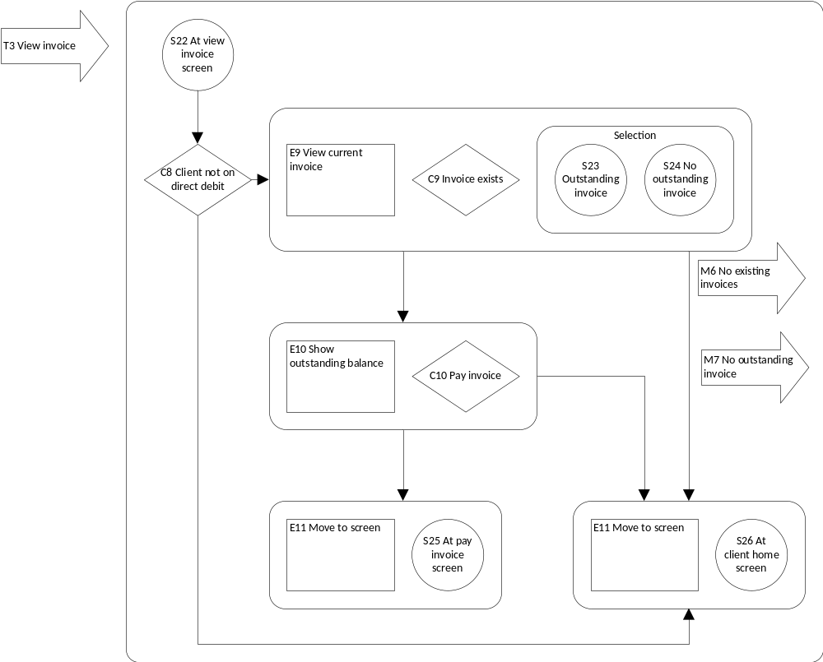

EVENT SPECIFICATION TABLE OF VIEW INVOICE

Event | Trigger | Message | Condition | Pre-state | Post-state | Rule
E9 | T3 |  | C8 | S22 | S23 | S24 | 3.1.5
E10 |  |  | C9 | S23 | S25 | 3.1.5
E11 | T3 |  | !C8 | S22 | S26 | 3.1.5
E11 |  | M6 | !C9 | S22 | S26 | 3.1.5
E11 |  | M7 | C9 | S24 | S26 | 3.1.5
E11 |  |  | !C10 | S23 | S26 | 3.1.5

BRD OF <ELABORATED USE CASE 4>

EVENT SPECIFICATION TABLE OF <ELABORATED USE CASE 4>

BRD OF <ELABORATED USE CASE 5>

EVENT SPECIFICATION TABLE OF <ELABORATED USE CASE 5>

REFERENCES

Cryo Cell Case Study.doc

Corona SDK, retrieved on August 20, from http://coronalabs.com/products/corona-sdk/

Australian Privacy Principles, retrieved on August 29, from http://www.oaic.gov.au/privacy/privacy-act/australian-privacy-principles

Perdue, Blake (2014) iOS 7 Wireframe kit, retrieved on September 26, from http://blakeperdue.com/ios7-wireframe-kit/

Hutchings, Stephen (2014) Typicons, retrieved on September 26, from http://www.flaticon.com/packs/typicons

LOGICAL RELATIONAL DATA MODEL
One diagram, one A4 page. Use Microsoft Visio to draw the diagram.

